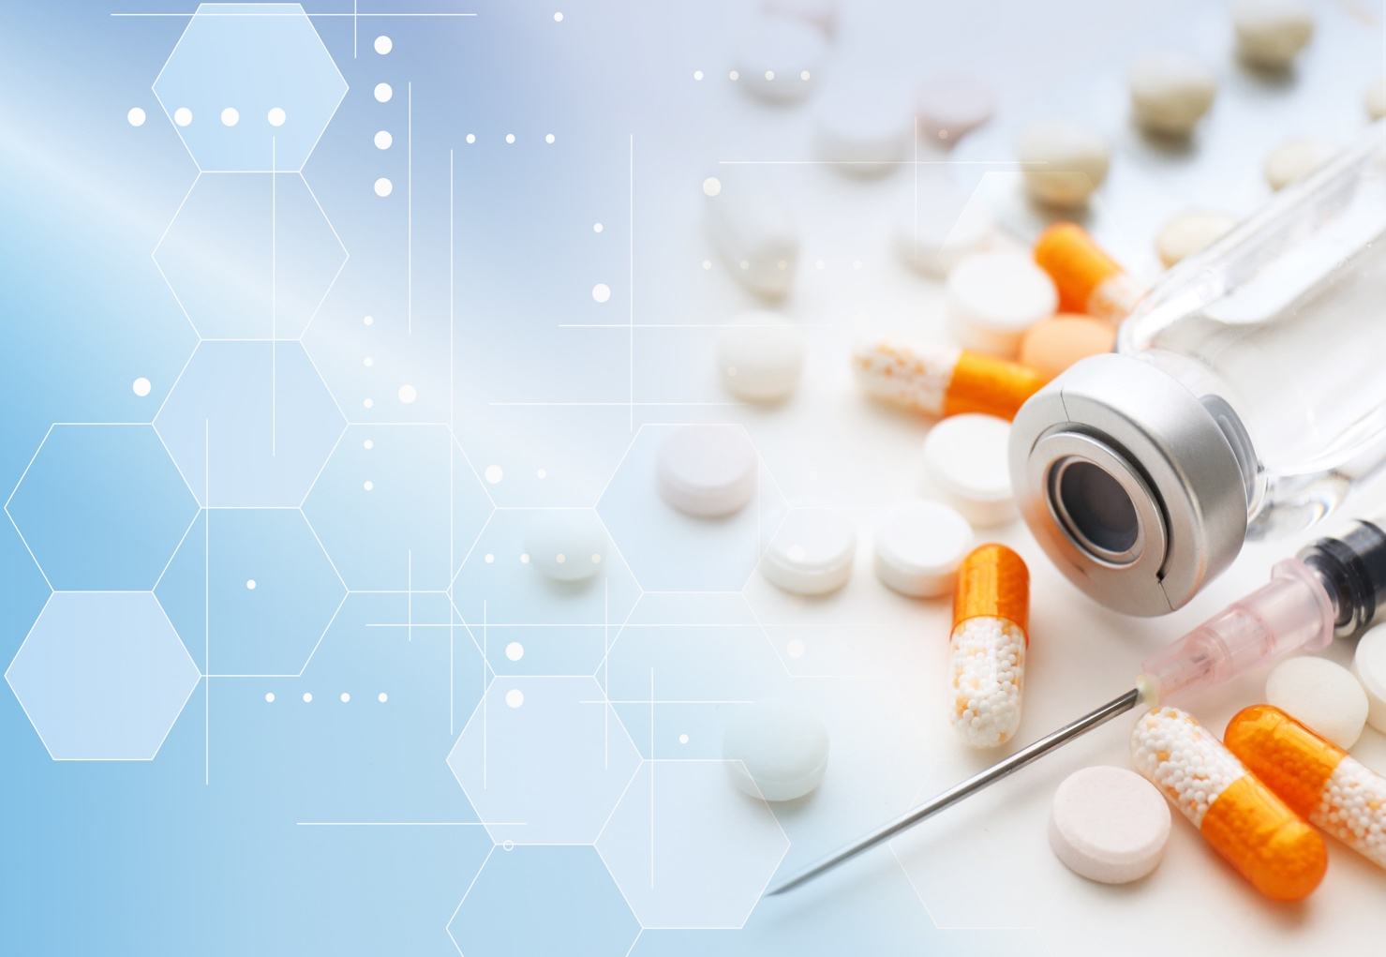
Emergency Contact Phone

Address
Name
MY HEALTHBOOK

Medicine  Name | Dose  Instruction | Reason
Blood Glucose (mg/dL or mmols/L)
Date | Fasting/Before meal | After meal

Medicine  Name | Dose  Instruction | Reason
Blood Pressure (mm of Hg)
Date | Systolic/Diastolic | Date | Systolic/Diastolic

