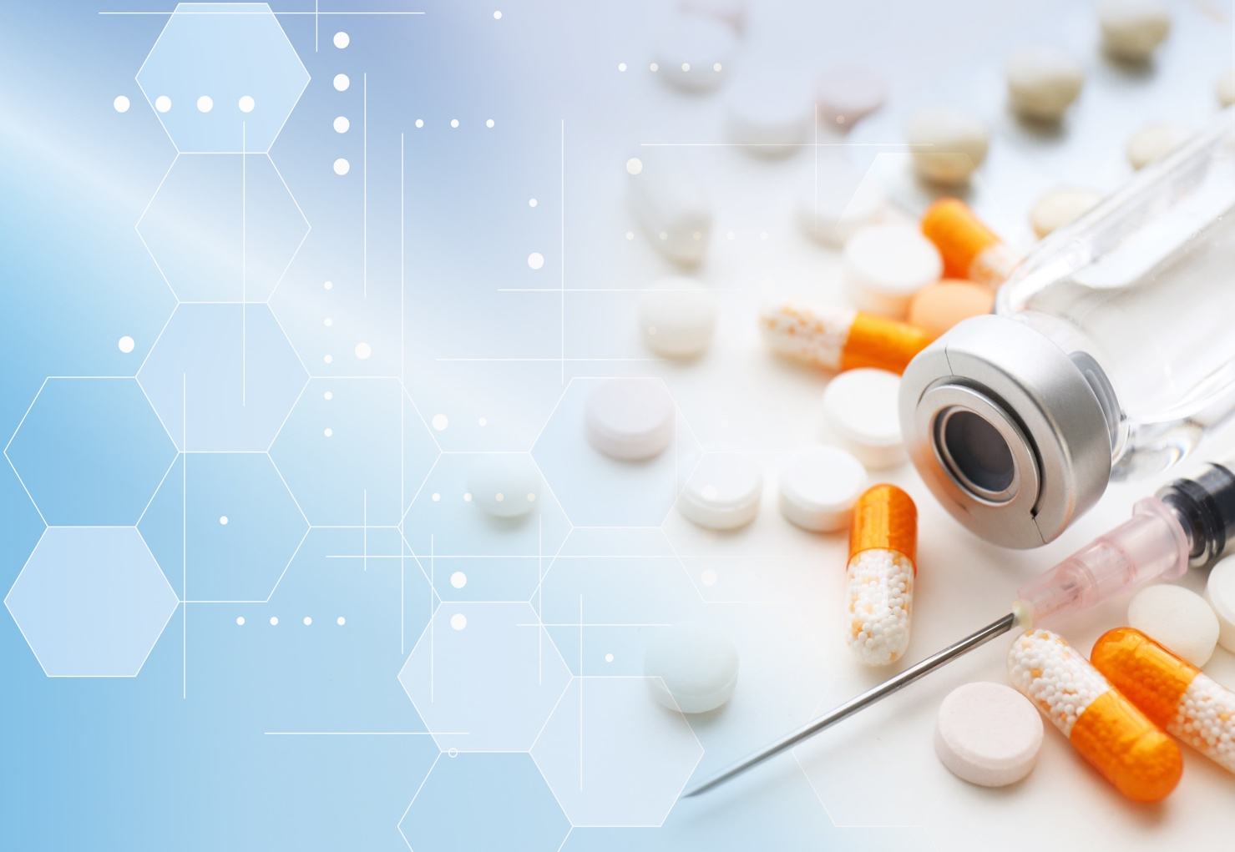
Emergency Contact Phone

Address
Name
MY HEALTHBOOK

Medicine  Name | Dose  Instruction | Date started | Reason
e.g Metformin | 1 tab twice a day  One before breakfast and one before dinner | 2003 | Diabetes
Medicine  Name | Dose Instruction | Date started | Reason

Blood Glucose
Date | Fasting/Before meal (mg/dL) | After meal  (mg/dL)
Blood Pressure (mm of Hg)
Date | Systolic/Diastolic | Date | Systolic/Diastolic

